Week 11 : Analysis and Design:

Data model/data set @ page 2 & 3

<https://www.scirp.org/journal/paperinformation?paperid=118849#f5>

Class diagram @ page 4 , 5 & 6

<https://www.freeprojectz.com/entity-relationship/voting-management-system-er-diagram>

<https://www.freeprojectz.com/uml-diagram/e-voting-management-system-sequence-diagram>

<https://www.freeprojectz.com/uml-diagram/e-voting-management-system-uml-diagram>

Activity diagram = Flowchart

Deployment Diagram@ page 7

Data model/data set

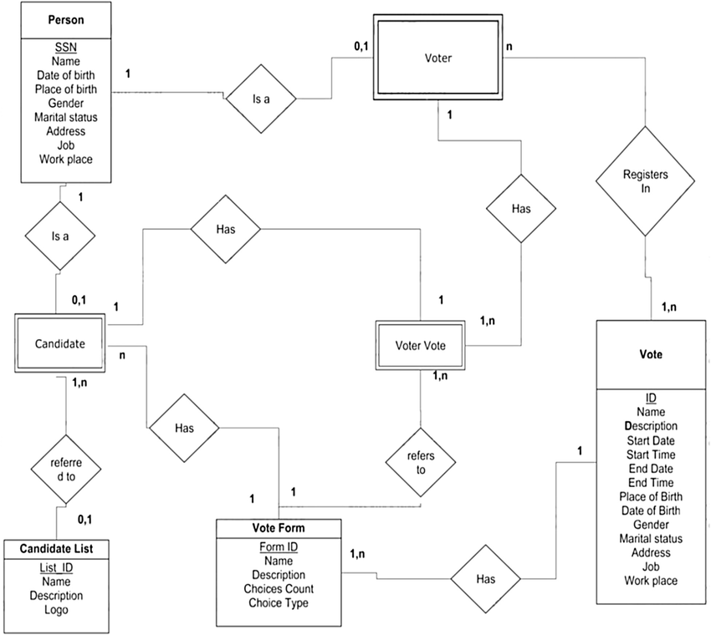

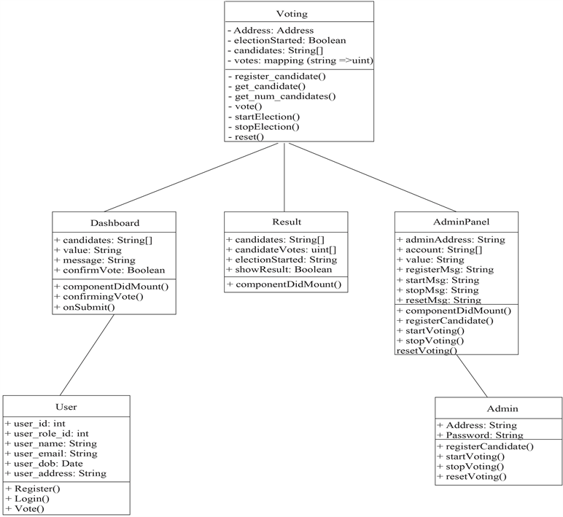

Class diagram

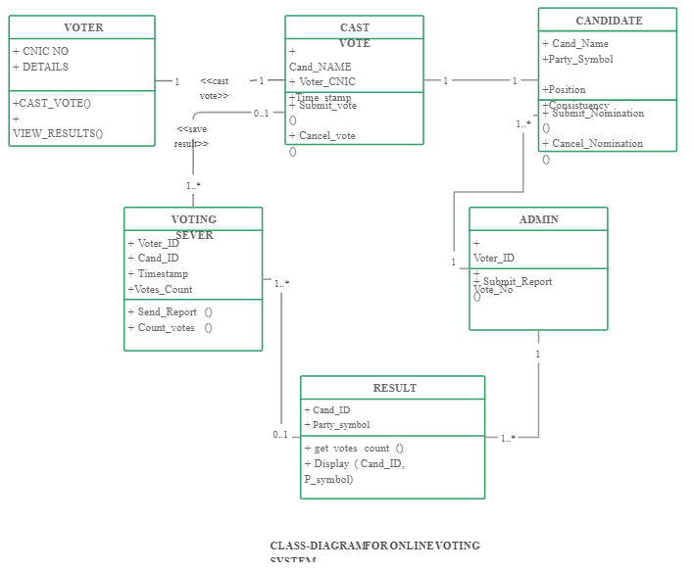

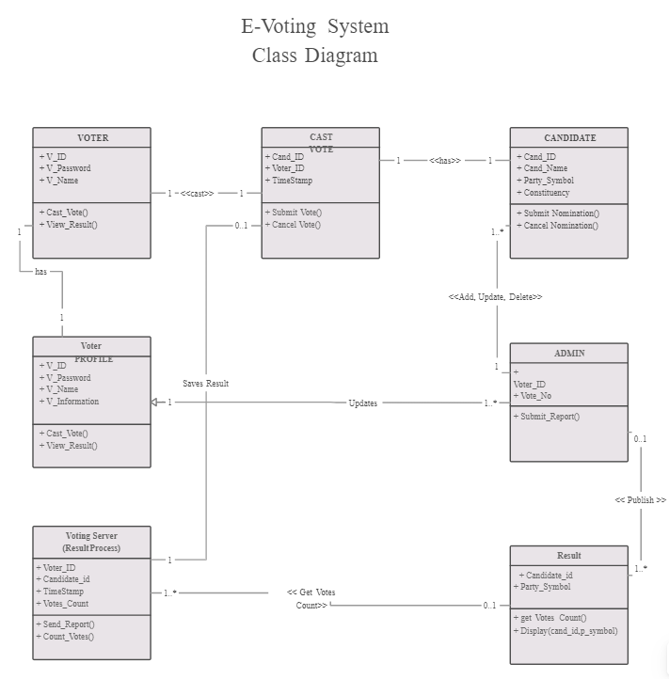

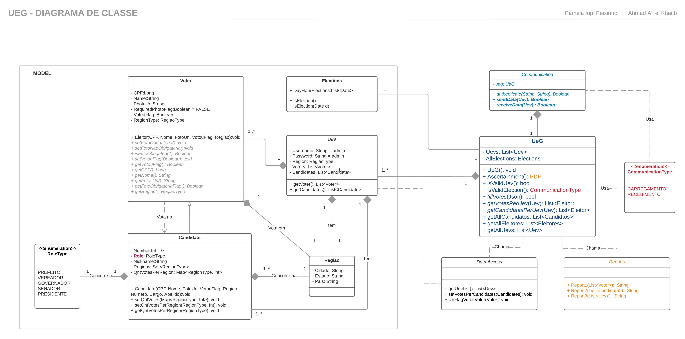

Deployment Diagram

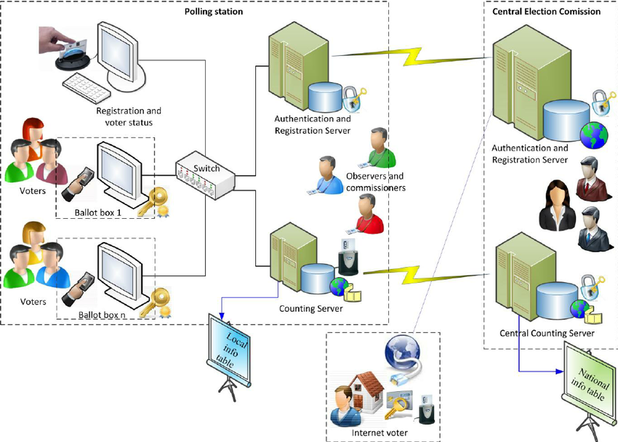

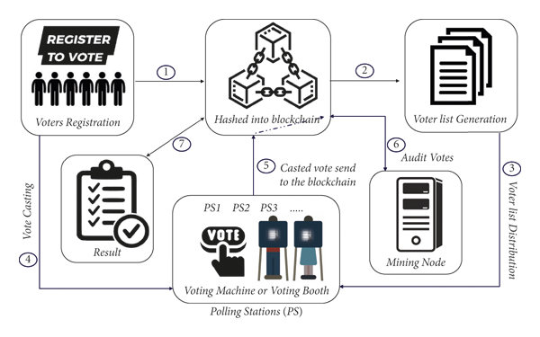

Week 12 :

Wireframe/Algorithm

🡪 UI not ready

🡪 Algorithm == Flowchart

flow chart/Input form design/Output Report Design@ page 9 & 10

flow chart

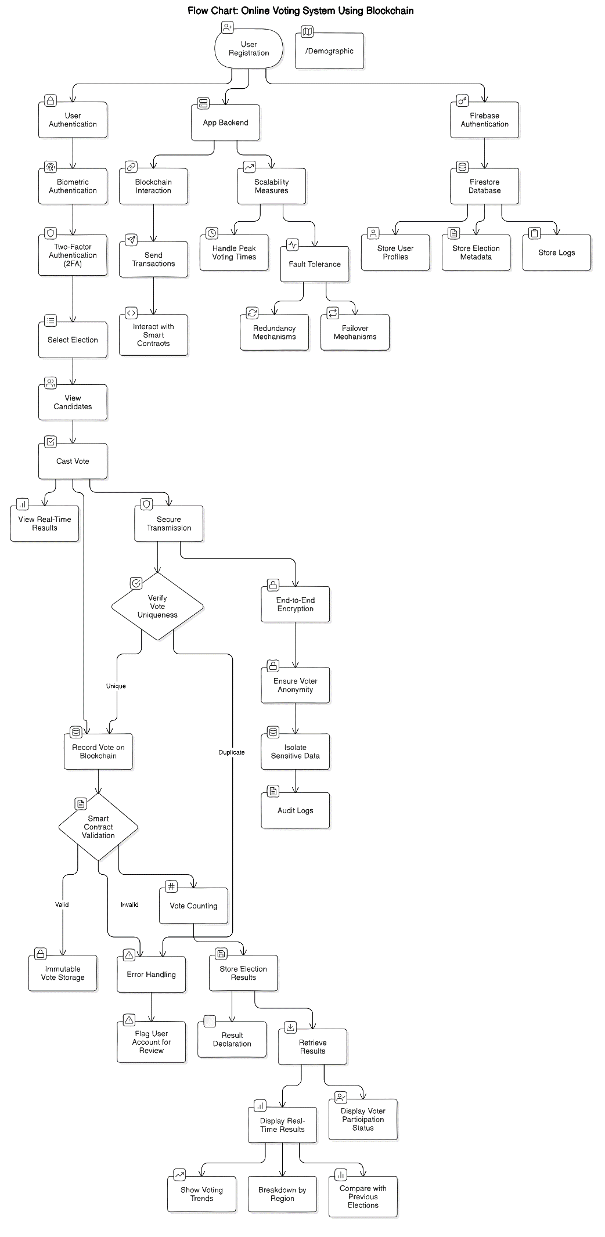

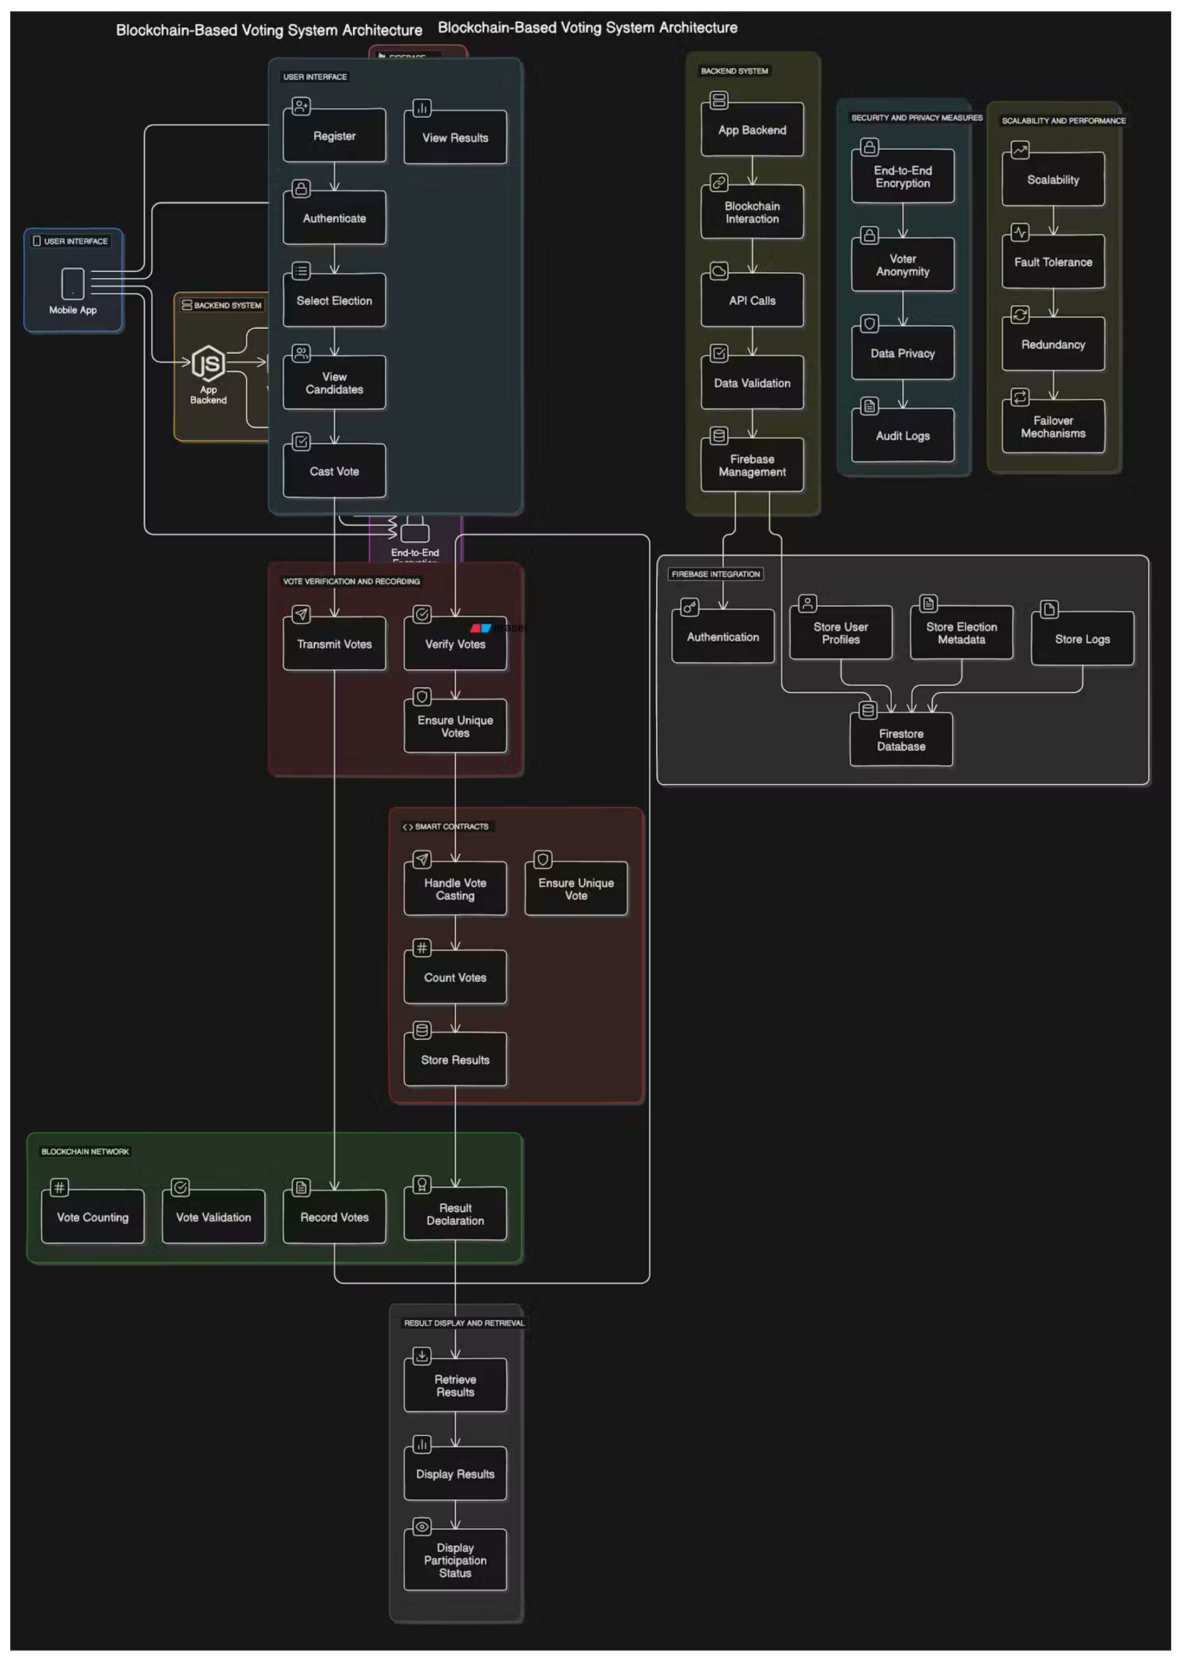

Week 13:

RMMM Plan @ page 12 & 13

Feasibility analysis @ page 14

Test case Dsign @ page 15

RMMM Plan

**RMMM Plan (Risk Mitigation, Monitoring, and Management)**

**Table: Risk Categories**

| **Risk ID** | **Risk Category** | **Probability** | **Impact** | **Description** | **Mitigation Plan** | **Monitoring Strategy** | **Management Strategy** |
| --- | --- | --- | --- | --- | --- | --- | --- |
| RMMM1 | **Scalability** | 60% | High | Ethereum’s transaction throughput may cause delays, especially in large elections. | Implement transaction batching and use a private blockchain for low-cost, high-speed transactions. | Monitor transaction processing times and user load during peak voting periods. | Scale the infrastructure dynamically during high traffic voting periods. |
| RMMM2 | **Security** | 50% | High | DDoS attacks could affect the backend or blockchain interaction, causing system downtime. | Strengthen backend security with rate limiting, firewalls, and distributed denial-of-service (DDoS) prevention mechanisms. | Continuous monitoring for unusual traffic patterns. | Activate fallback systems and reroute traffic to unaffected nodes. |
| RMMM3 | **Privacy** | 30% | High | Sensitive voter data may be exposed due to insufficient encryption or data management practices. | Implement end-to-end encryption for all sensitive data transfers and storage. | Regular audits of encryption protocols and data flow paths. | Ensure legal compliance with privacy regulations; isolate sensitive data in blockchain. |
| RMMM4 | **System Downtime** | 20% | Moderate | Unexpected system downtime may cause disruption in elections. | Deploy backup servers and failover systems to ensure high availability. | Track system performance, uptime, and downtime metrics. | Have emergency support available for immediate issue resolution. |
| RMMM5 | **Integration Failures** | 40% | Moderate | Integration between the mobile app, backend, and blockchain may face challenges. | Implement continuous integration testing for app-backend-blockchain workflows. | Monitor API responses, transaction failures, and timeout issues. | Develop fallback logic to handle temporary disconnections gracefully. |

Feasibility analysis

**Feasibility Analysis**

**Technical Feasibility**

* **Blockchain for Vote Storage**: Ethereum or a similar blockchain network ensures secure, immutable, and tamper-proof vote storage. Smart contracts enable vote counting and ensure that no duplicate voting occurs.
* **Firebase for Metadata**: Storing non-sensitive data such as voter logs and metadata in Firebase provides a cost-effective and efficient solution for off-chain operations, reducing blockchain transaction costs.
* **User-Friendly Authentication**: Multi-factor authentication (MFA) with biometric verification provides a secure and easy way for voters to register and authenticate.

**Financial Feasibility**

* **Cost of Blockchain Transactions**: Public blockchains like Ethereum have transaction costs, but this can be minimized by using Layer 2 scaling solutions or consortium blockchains. Additionally, operations such as vote recording are optimized to avoid unnecessary costs.
* **Firebase Usage Costs**: Firebase is utilized for handling non-voting-related metadata and logs, which reduces the need for on-chain storage, keeping costs low.

**Operational Feasibility**

* **Ease of Use**: The mobile app is designed for ease of use, with a straightforward interface for voters to register, select elections, and cast votes. Multi-factor authentication ensures that even non-technical users can participate securely.
* **Handling Peak Voting Periods**: The system is scalable to handle a large number of users during peak voting times, ensuring that even national elections can be conducted smoothly.

Test case Dsign

**Test Case Design**

**1. Authentication Test**

* **Description**: Verify that the user authentication system works correctly with multi-factor authentication (password, biometric, OTP).
* **Input**: Voter enters email/password, biometric data, and receives OTP.
* **Expected Output**: Successful login, access granted to the dashboard.

**2. Vote Casting Test**

* **Description**: Ensure that votes are securely cast and recorded on the blockchain.
* **Input**: User selects election and candidate, confirms vote.
* **Expected Output**: Vote is recorded on the blockchain, transaction hash is returned, and confirmation message is displayed to the user.

**3. Duplicate Voting Prevention**

* **Description**: Ensure that users cannot vote more than once in the same election.
* **Input**: User attempts to cast a vote for the second time in the same election.
* **Expected Output**: Error message indicating that the user has already voted, and no new transaction is created on the blockchain.

**4. Result Display Test**

* **Description**: Validate that real-time results are fetched from the blockchain and displayed correctly.
* **Input**: User queries election results after voting ends.
* **Expected Output**: Real-time results fetched and displayed from the blockchain, showing vote counts by candidate and overall turnout.

**5. Data Encryption and Security Test**

* **Description**: Verify that all sensitive data, including votes and user details, are encrypted during transmission and storage.
* **Input**: Vote data submitted by the user.
* **Expected Output**: Data is encrypted during transmission, verified by checking the blockchain records and ensuring sensitive information remains confidential.

**6. Scalability Test**

* **Description**: Assess the system’s ability to handle a high number of concurrent users.
* **Input**: Simulate thousands of users casting votes simultaneously.
* **Expected Output**: The system should process all votes with minimal latency and no downtime, showing no degradation in performance.

**7. Failover and Recovery Test**

* **Description**: Ensure that the system can recover from failures such as server crashes or blockchain node disconnection.
* **Input**: Simulate a backend server crash during voting.
* **Expected Output**: The system automatically switches to a backup server with no data loss or impact on ongoing voting processes.